**Food Mine**

https://www.youtube.com/watch?v=Uci0L4k3TQo&list=PLpaspowtqj-dA0cRZ1yEZBv0iwdOru-SC&index=3&ab_channel=CodeWithNasir

|  |  |
| --- | --- |
|  | ##  Lessons |
| 2 | 1. Introduction to the course |
| 3 | 2. Install development tools |
| 4 | 3. Create Angular App |
| 5 | 1. Create project's folder |
| 6 | 2. Install @angular/cli |
| 7 | 3. Create App as frontend |

Instalando

*Npm install -g @angular/cli*

*Ng new frontend -–skip-tests*

*Ou*

*sudo npm install -g @angular/cli@13*

*Ou*

INSTALAR LOCALMENTE *sudo npm install @angular/cli@13*

*Npm install*

Criar past front end

*ng new frontend - -minimal*

*Y Y CSS*

*Cd frontend*

*Ng serve -o ou npm start*

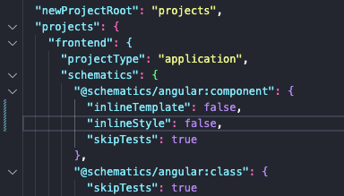

|  |  |  |
| --- | --- | --- |
|  | 4. Add Header 9 | 1. Generate Component |
| 10 | 2. Add Html |
| 11 | 3. Add Css |

*Ng g c components/partials/header*

Usar dois terminais para garatinr que um rode o codigo, e outro para commandos.

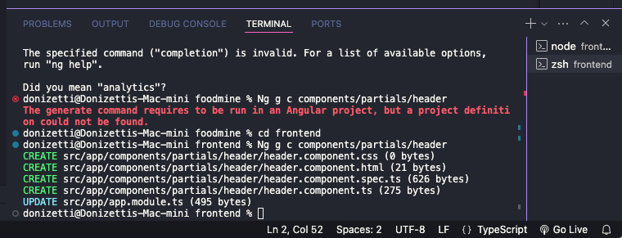

*Importando header no* app.component.html

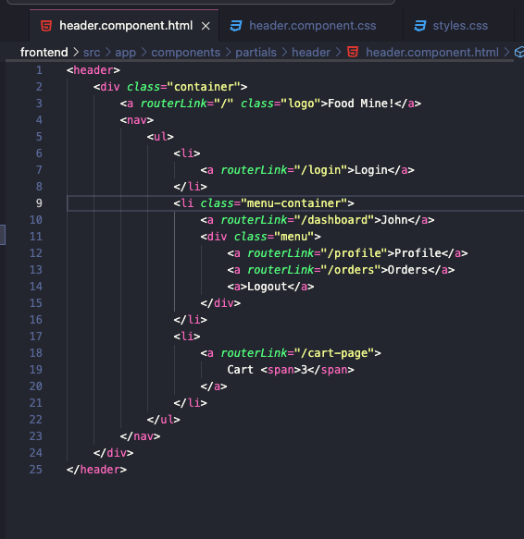

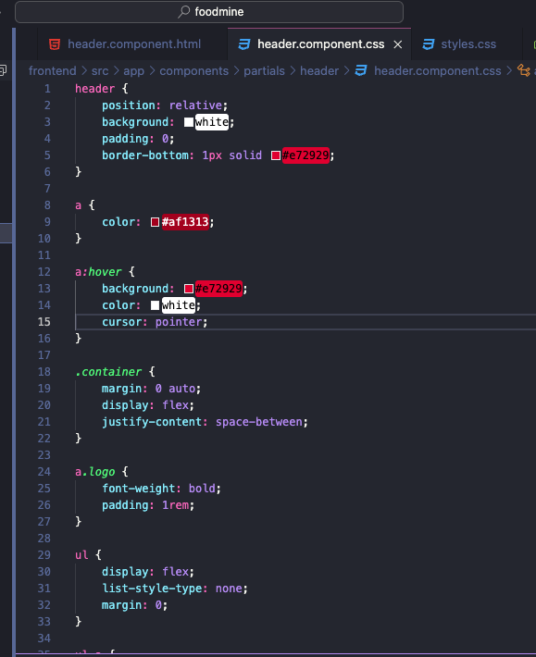

|  |  |
| --- | --- |
|  | 5. List Foods |
|  | 1. Create Food model |
|  | 2. Create data.ts |
|  | 1. Add sample foods |
|  | 3. Add images to assets |
|  | 4. Create Food service |
|  | 5. Create Home component |
|  | 1. Add ts |
|  | 2. Add html |
|  | 3. Add |

1

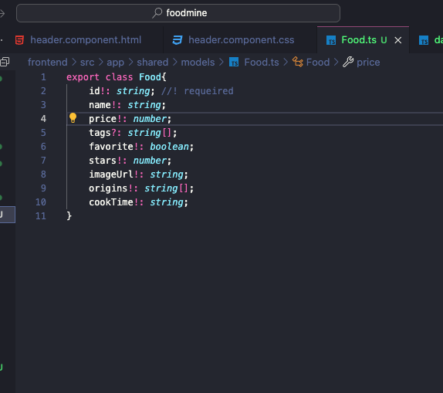

2

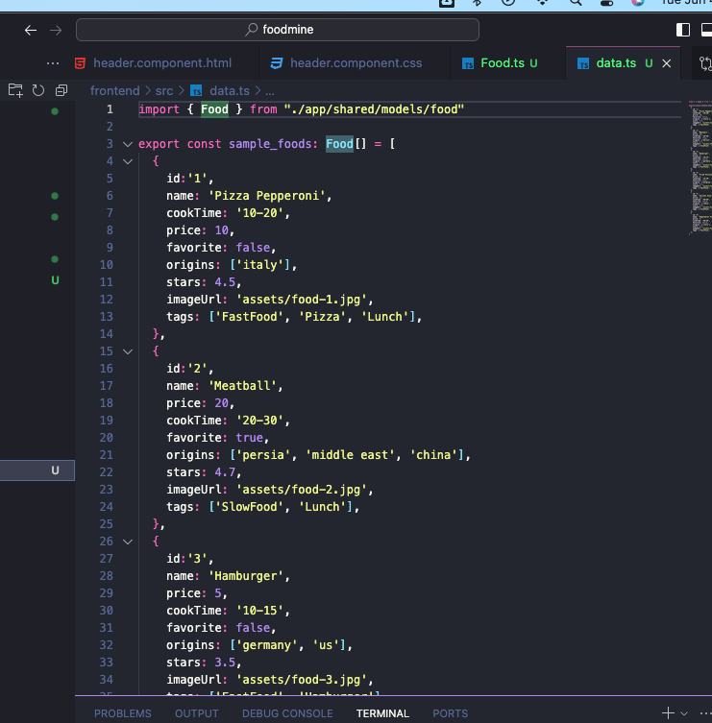

Import iamges

*ng g s service/food*

*cmd + .*

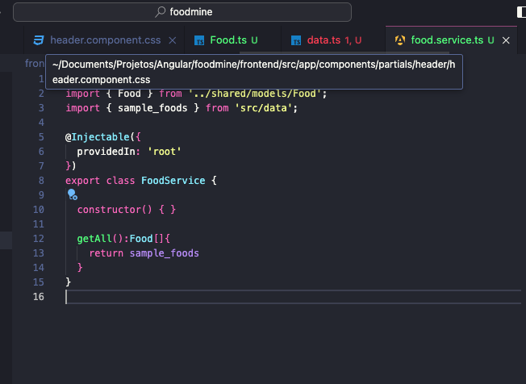

*5*

*ng g c components/pages/home*

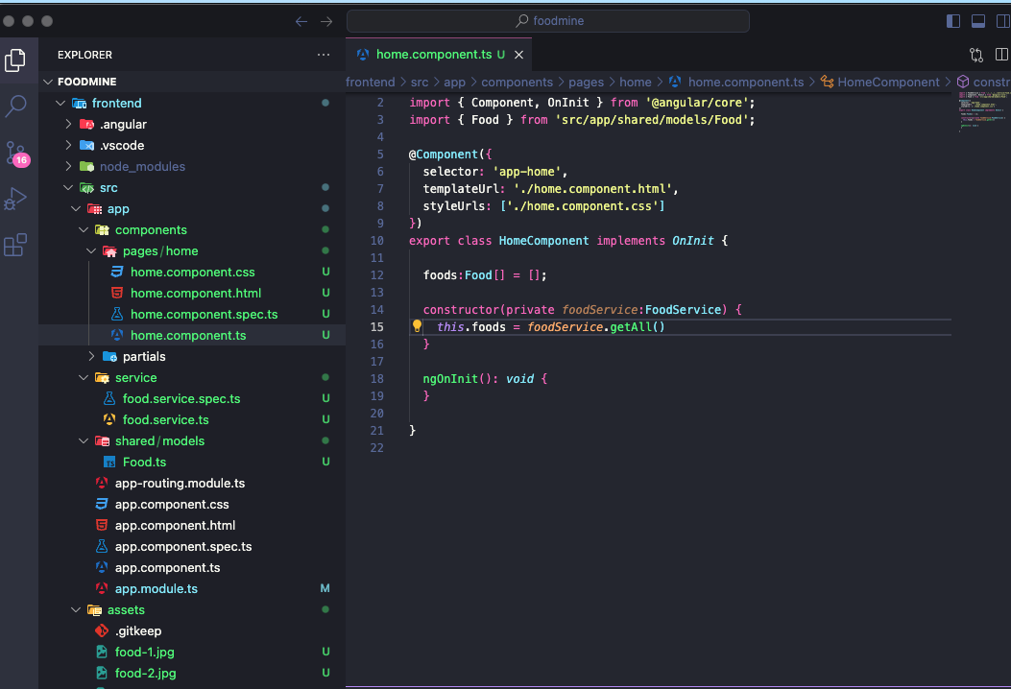

Instalar *npm install ng-starrating –force*

Importar em app modules

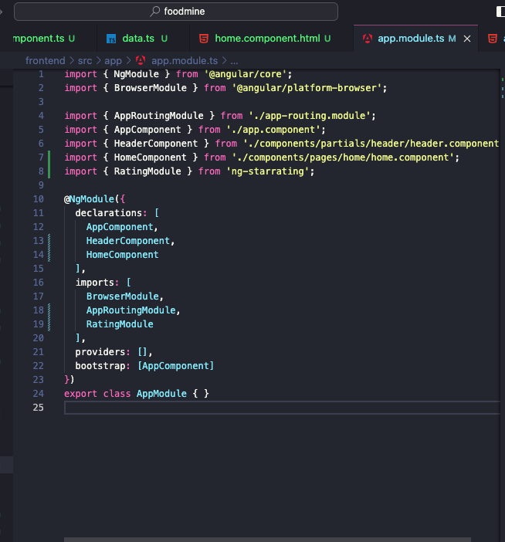

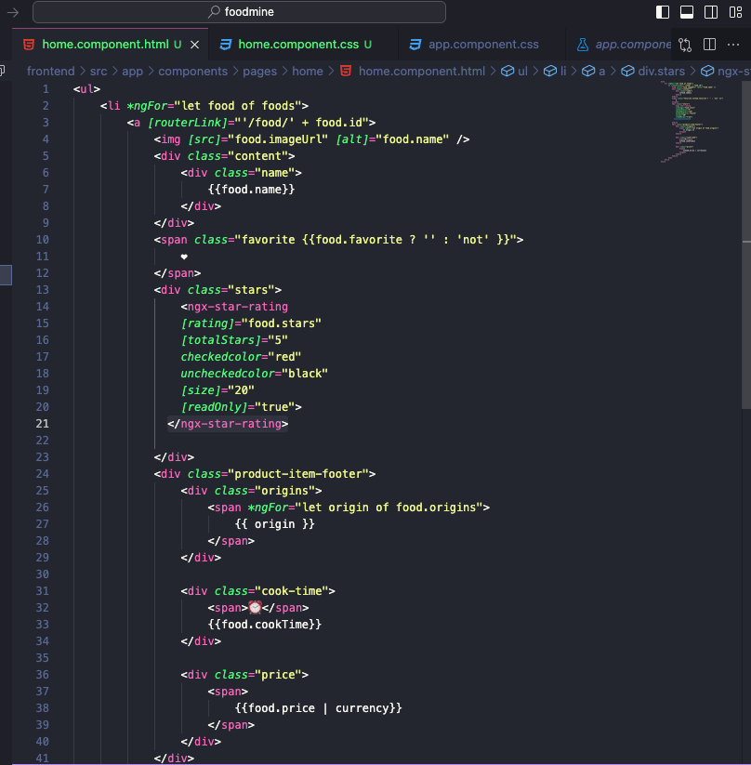

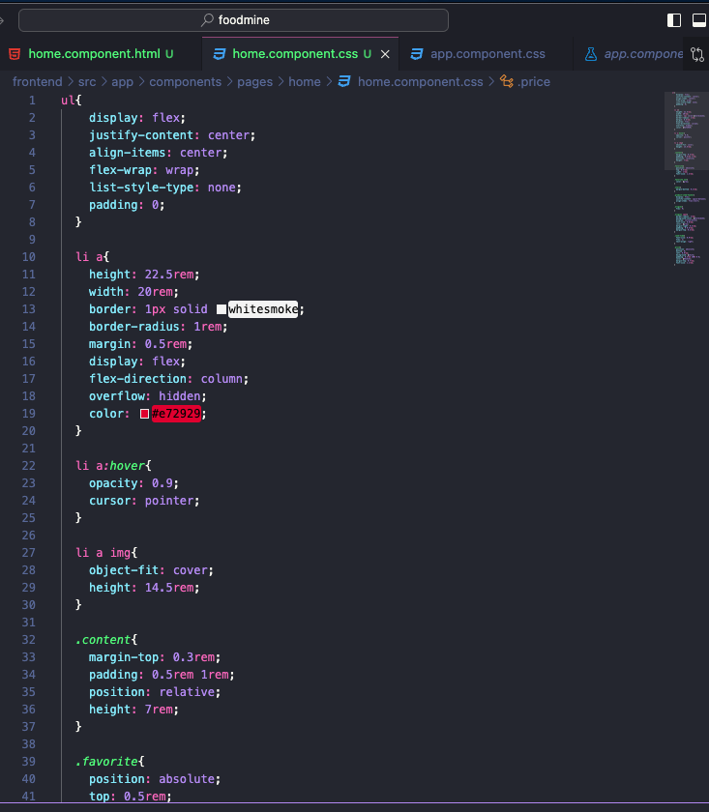

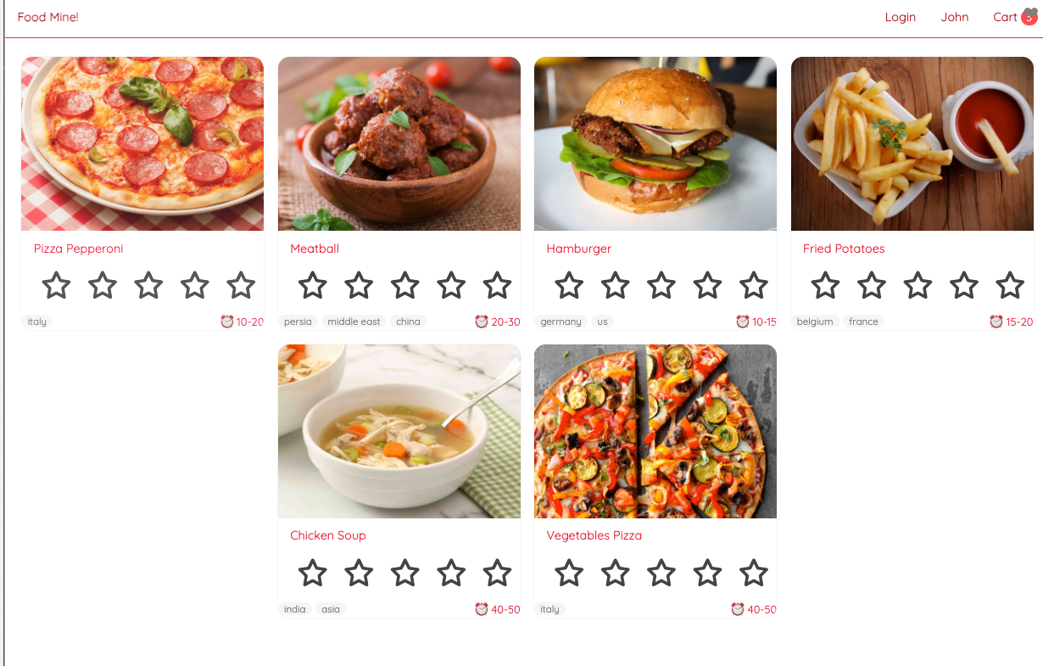

6. Search

1. ﻿﻿﻿Add method to Food service
2. ﻿﻿﻿Add search route
3. ﻿﻿﻿Show search result in Home component
4. ﻿﻿﻿Generate search component
5. ﻿﻿﻿Add to home component
6. ﻿﻿﻿Add ts
7. ﻿﻿﻿Add html

﻿﻿﻿Add css

1

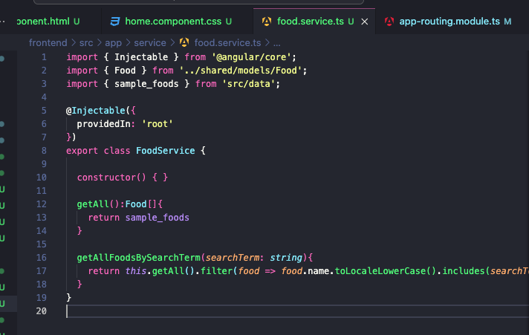

2

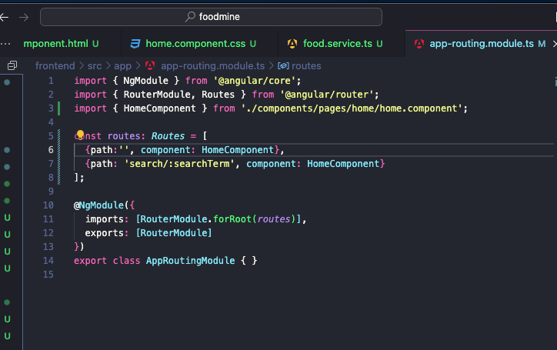

3

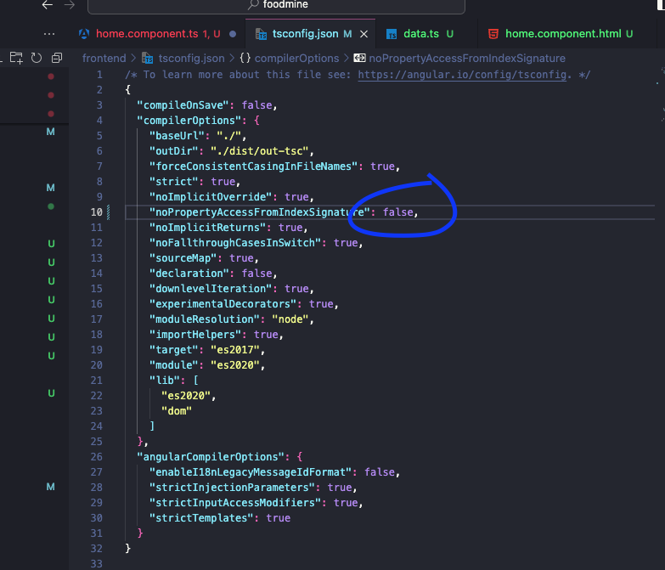

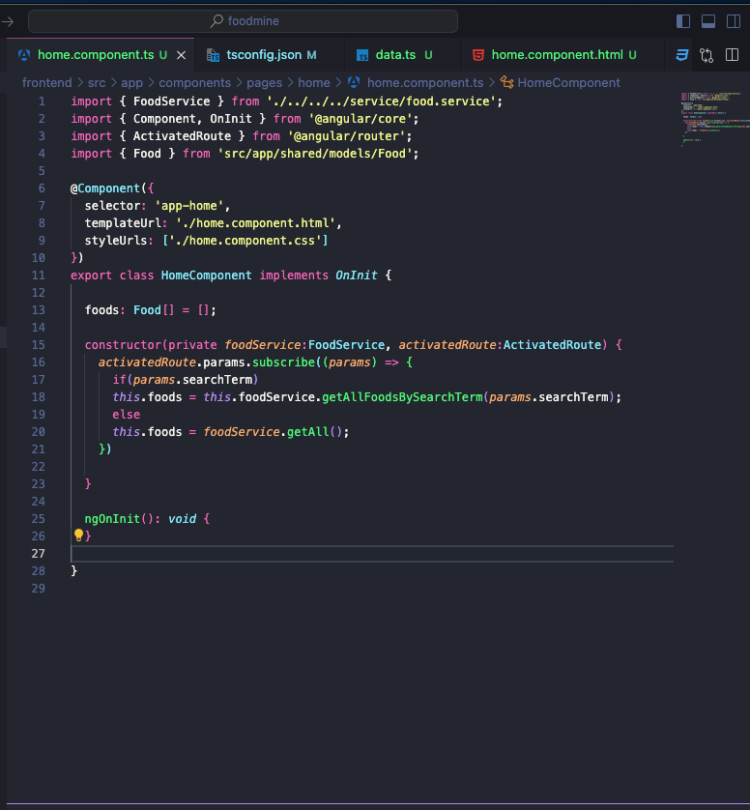

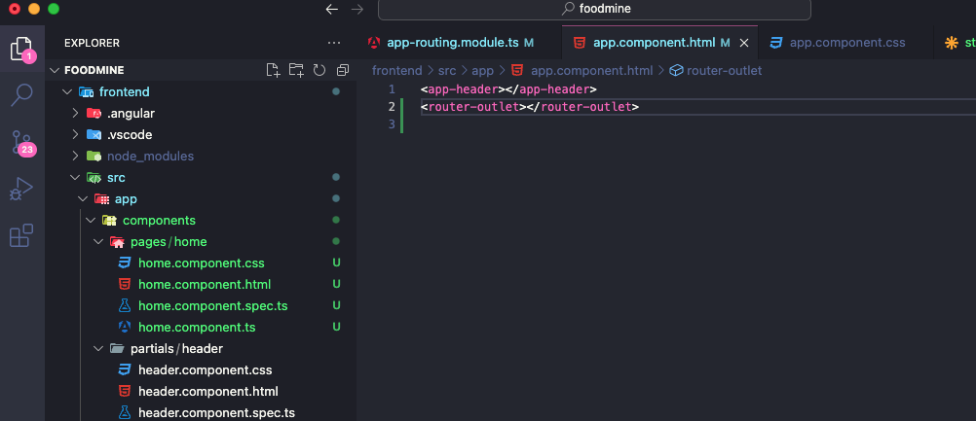

4

*ng g c components/partials/search*

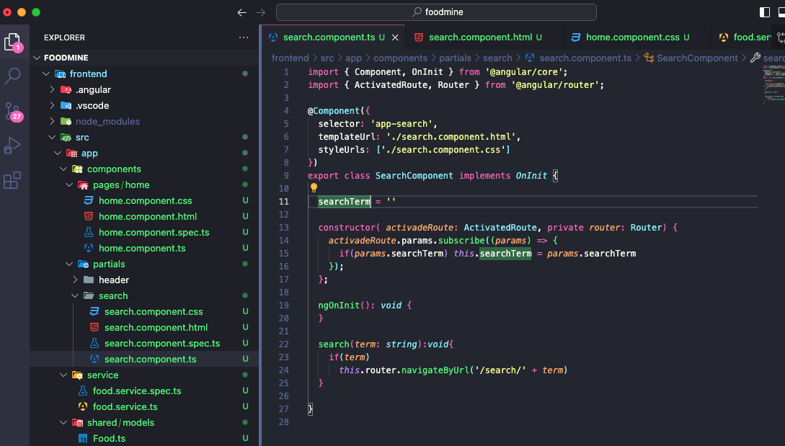

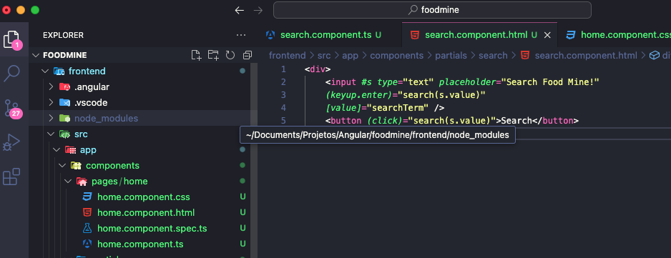

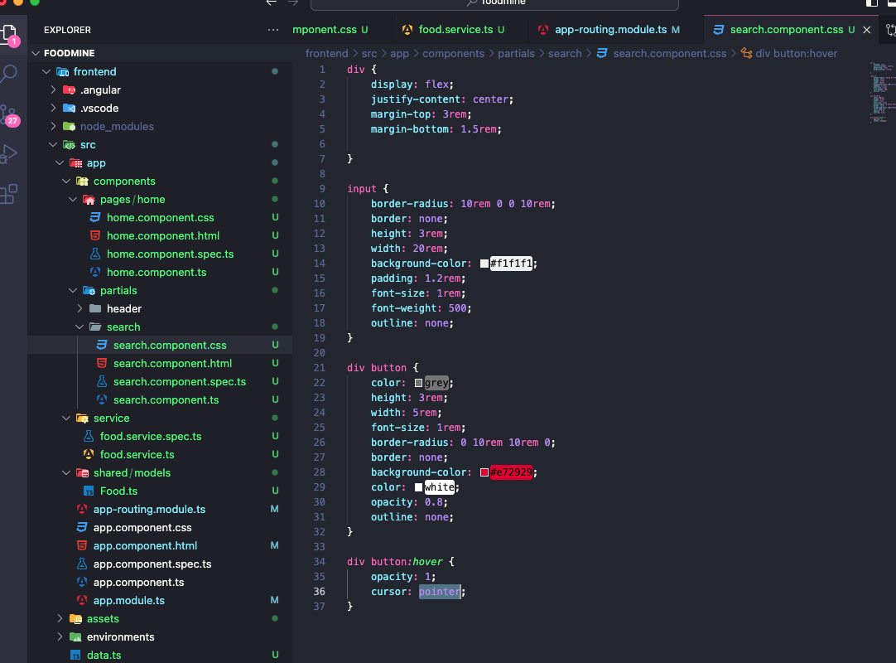

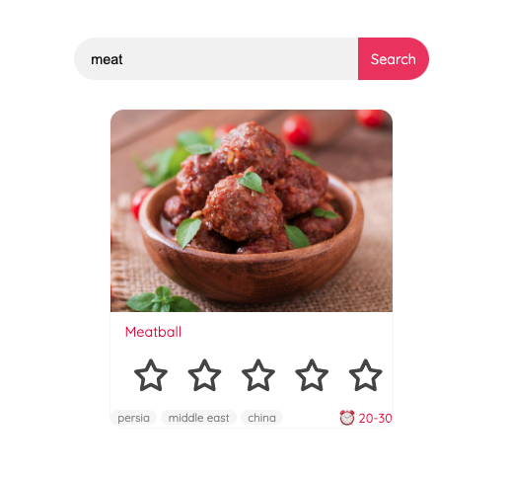

8. Food Page

1. ﻿﻿﻿Add method to food service
2. ﻿﻿﻿Generate Food Page component
3. ﻿﻿﻿Add Route
4. ﻿﻿﻿Add ts
5. ﻿﻿﻿Add html

﻿﻿﻿Add css

5

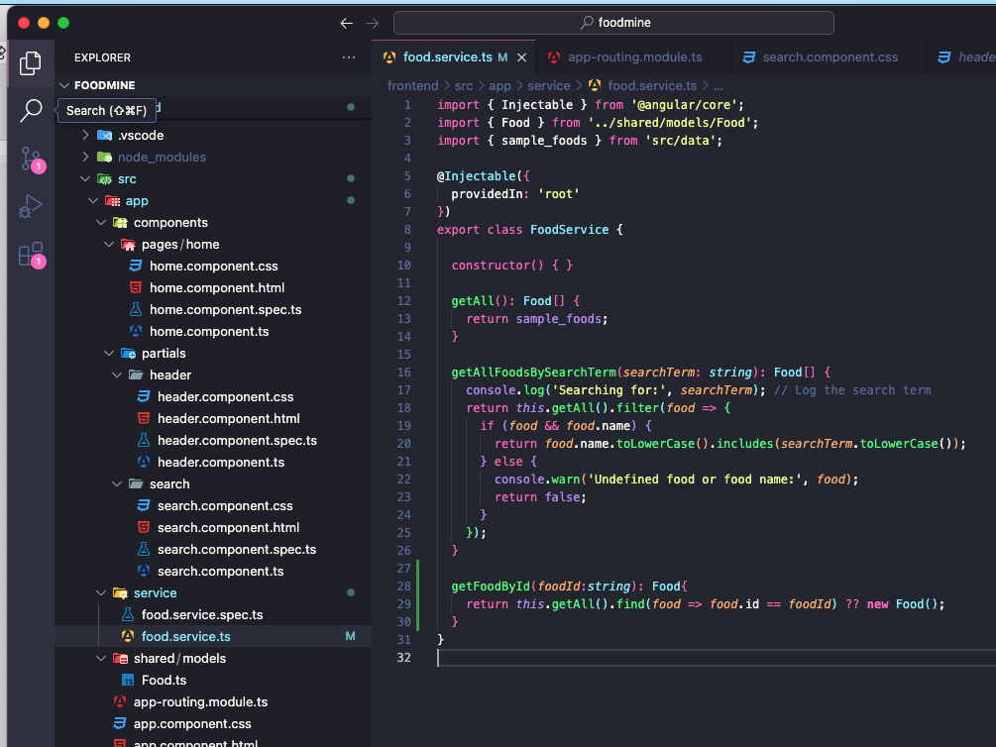

*ng g c components/pages/food-page*

*4*

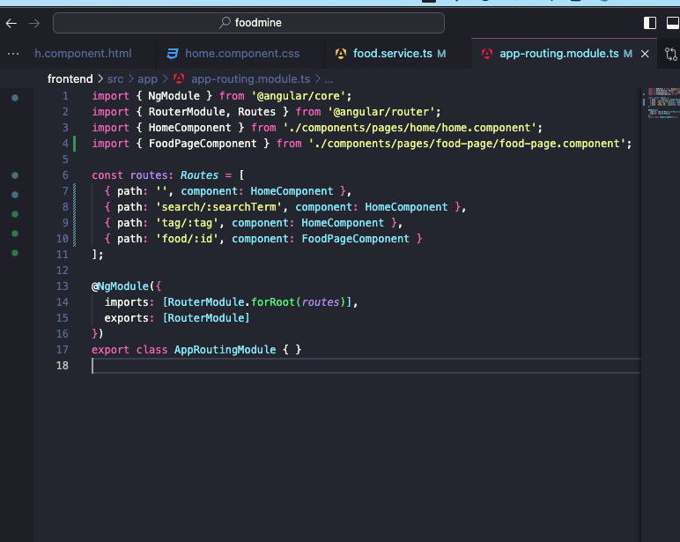

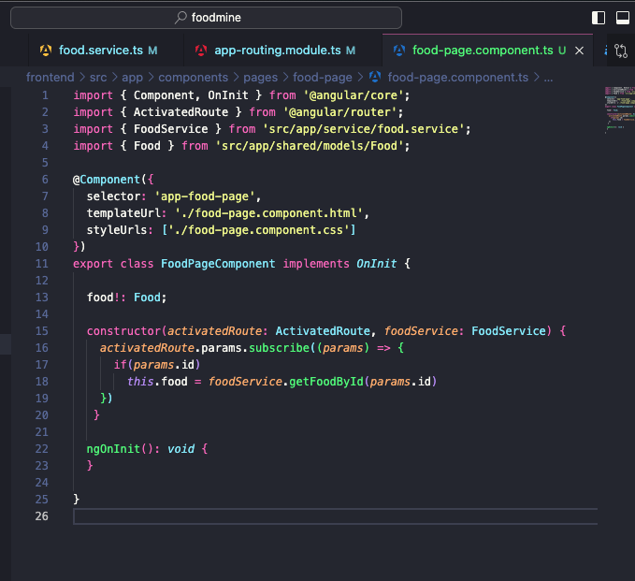

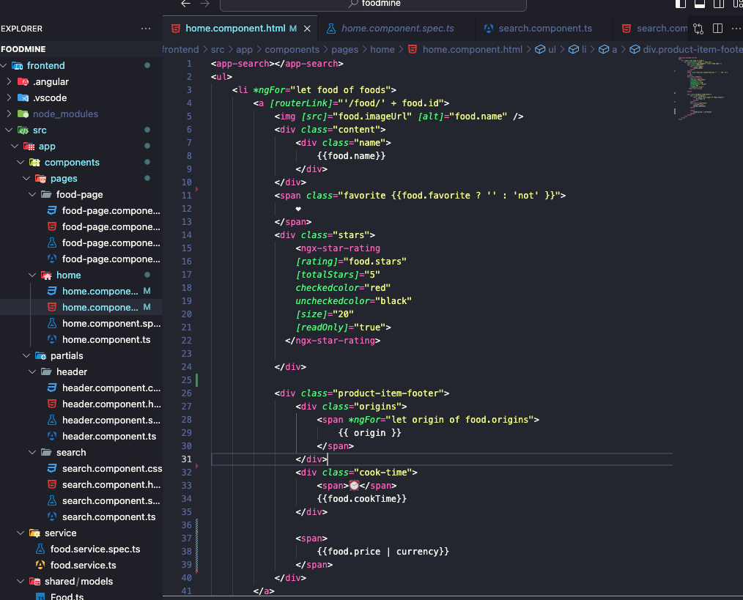

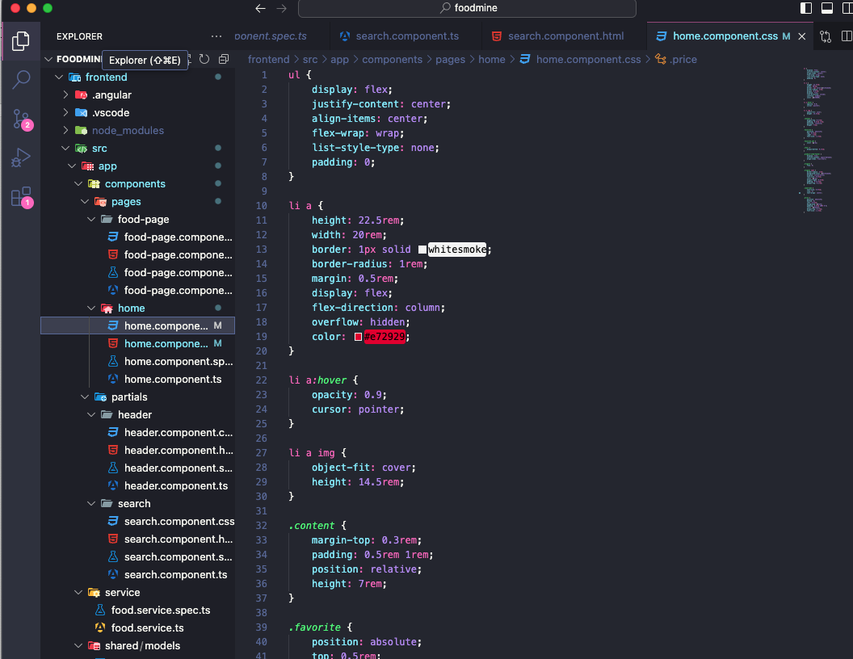

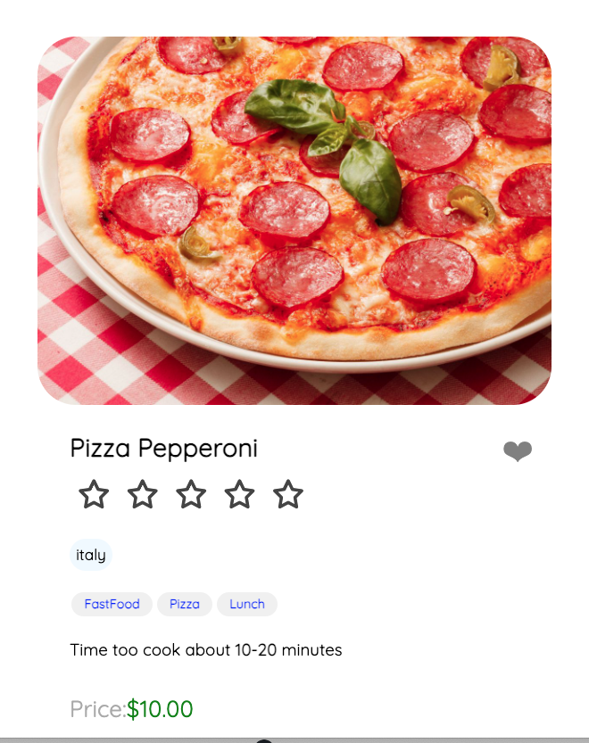

7. Tags Bar

|  |  |
| --- | --- |
|  | 1. Create Tag model |
|  | 2. Add sample tags to data.ts |
|  | 3. Food service |
|  | 1. Add get all tags method |
|  | 2. Add get all foods by tag method |
|  | 4. Add tags route |
|  | 5. Show tag result in Home component |
|  | 6. Generate Tags component |
|  | 1. Add to home component |
|  | 2. Add ts |
|  | 3. Add html |
|  | 4. Add css |

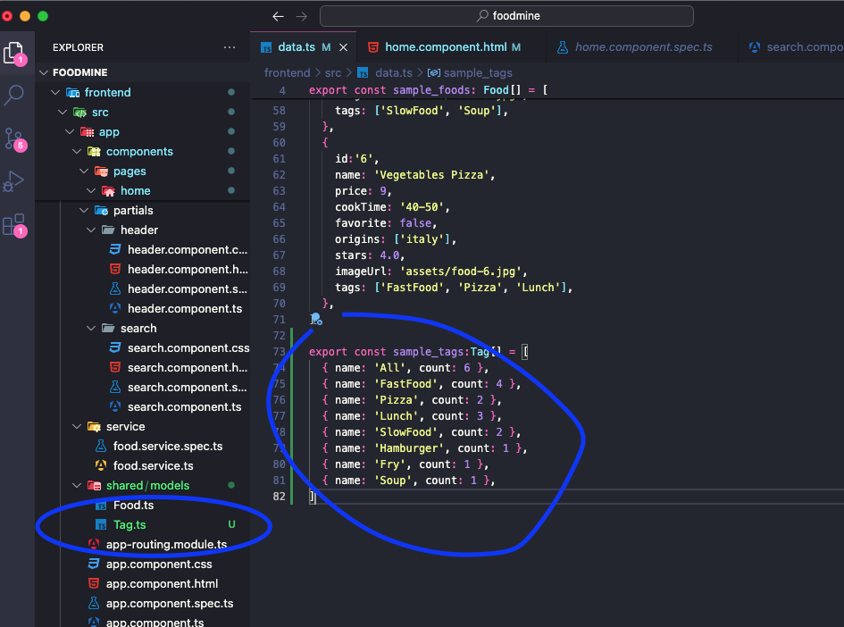

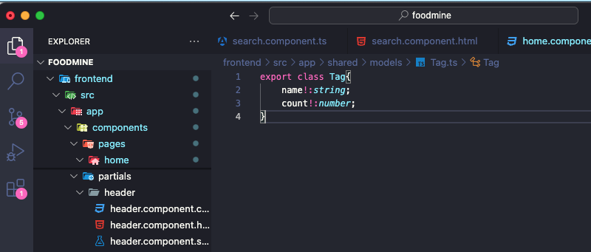

*31 32*

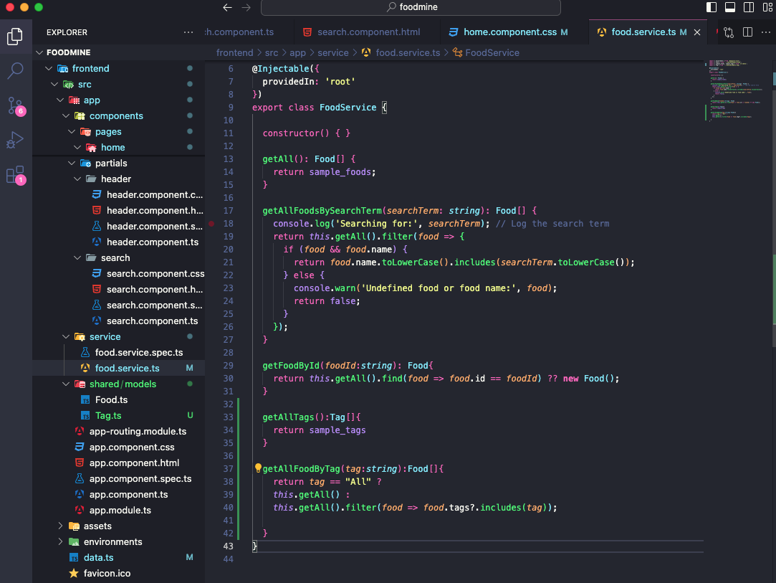

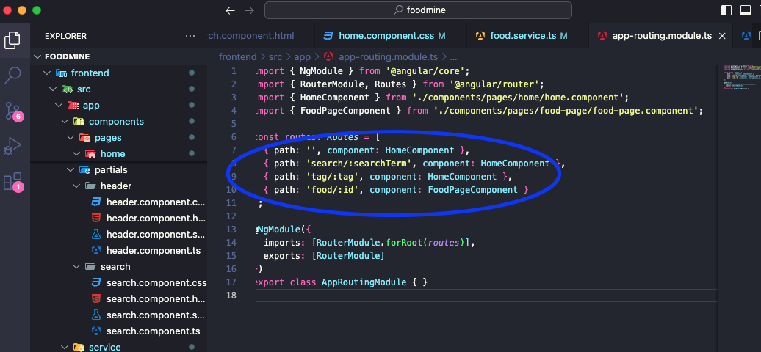

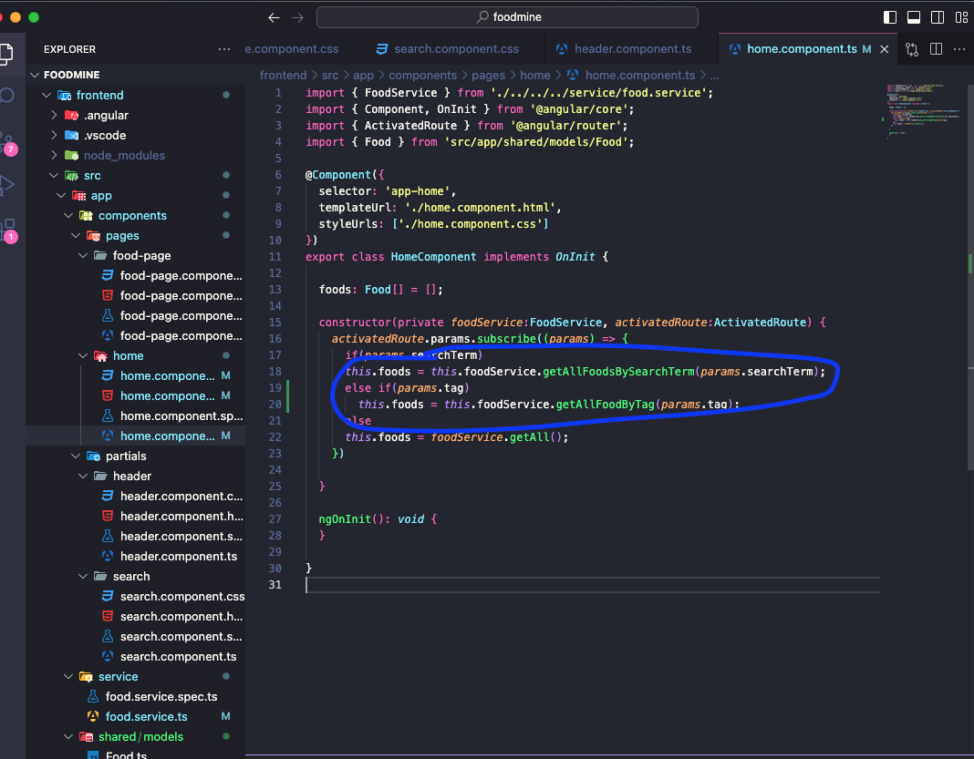

*ng g c components/partials/tags*

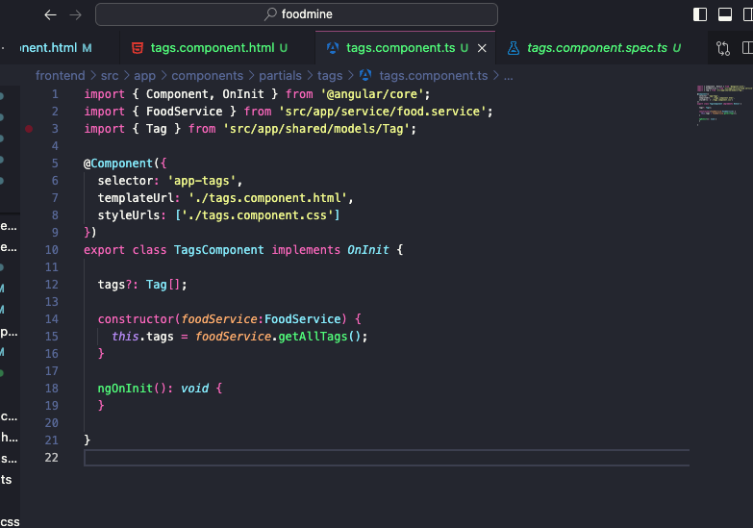

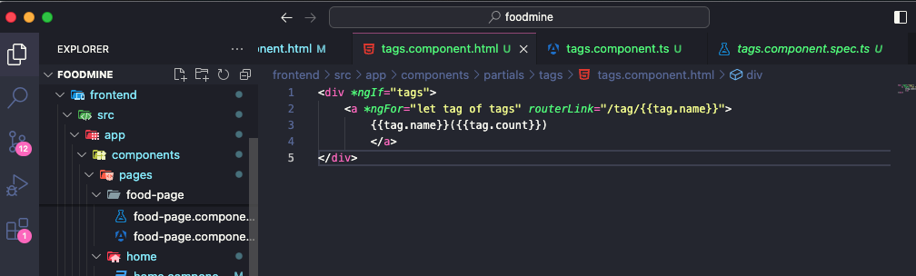

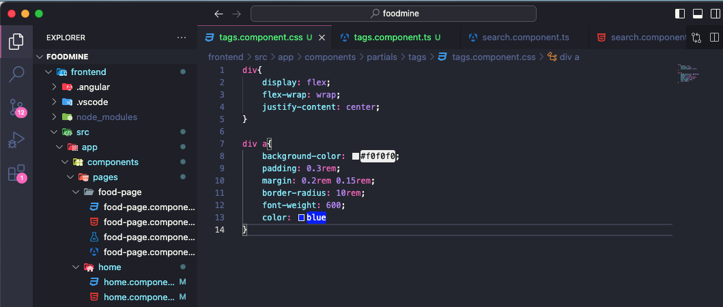

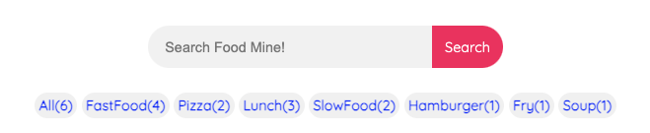

*8*

*Cart Page*

*1. Create CartItem Model*

*2. Create Cart Model*

*3. Generate Cart service*

*4. Add to Cart Button in Food Page*

*5. Generate Cart page component*

*1. Add Route*

*2. Add ts*

*3. Add html*

*4. Add css*

*1*

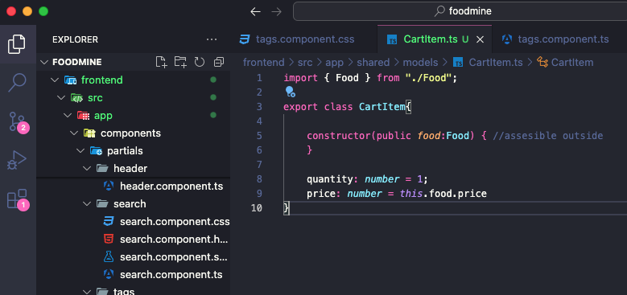

*2*

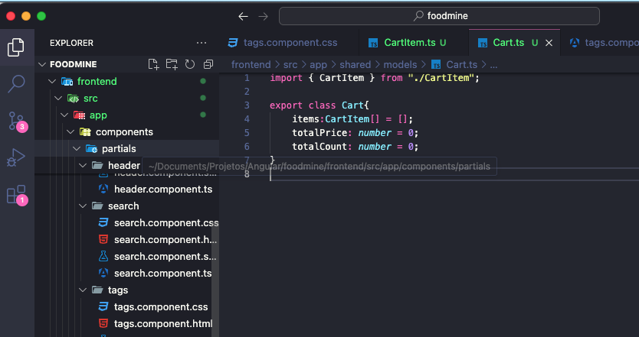

*3*

*ng g s service/cart*

[*https://www.youtube.com/watch?v=mLqBQVexy0c&list=PLpaspowtqj-dA0cRZ1yEZBv0iwdOru-SC&index=8&ab_channel=CodeWithNasir*](https://www.youtube.com/watch?v=mLqBQVexy0c&list=PLpaspowtqj-dA0cRZ1yEZBv0iwdOru-SC&index=8&ab_channel=CodeWithNasir)

Carrinho de compras - DIFICL

*4*

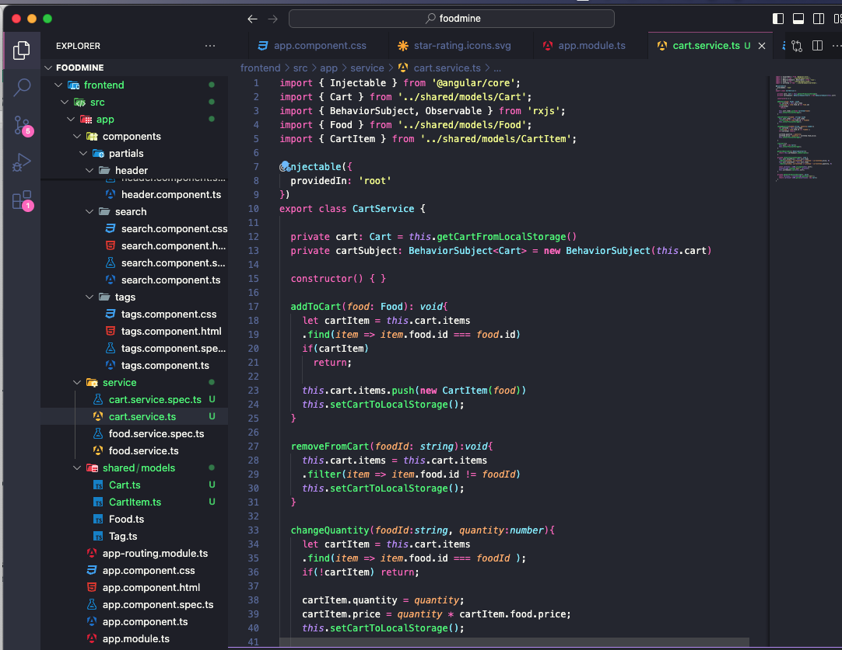

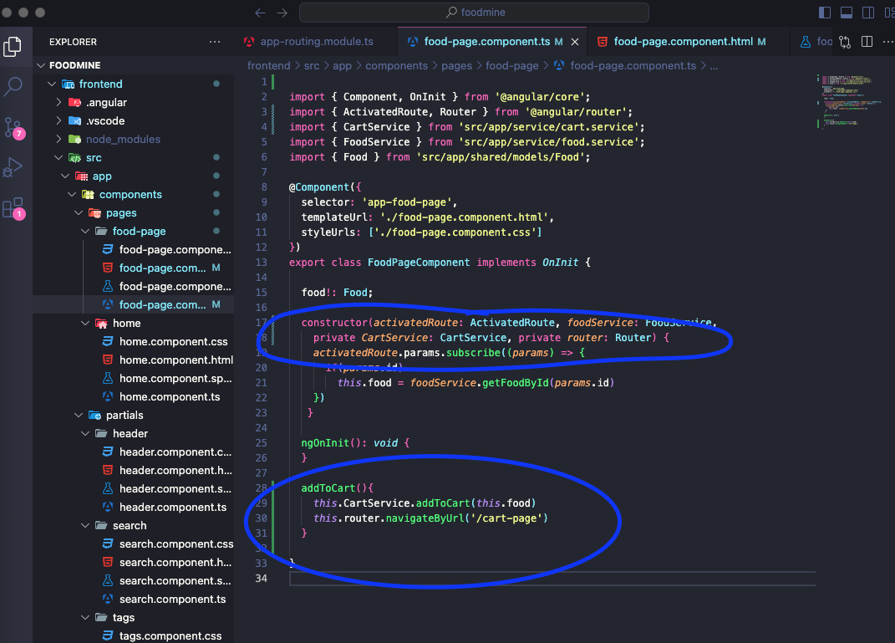

*ng g c components/pages/cart-page*

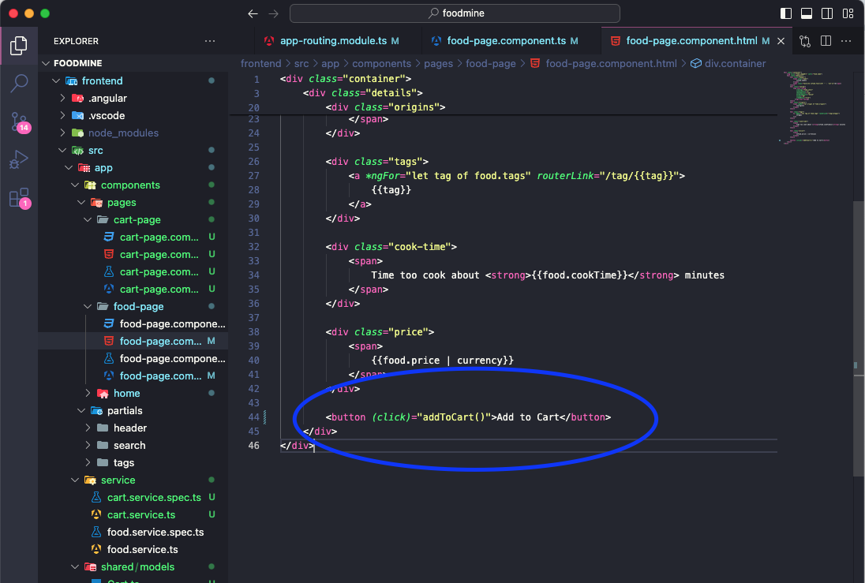

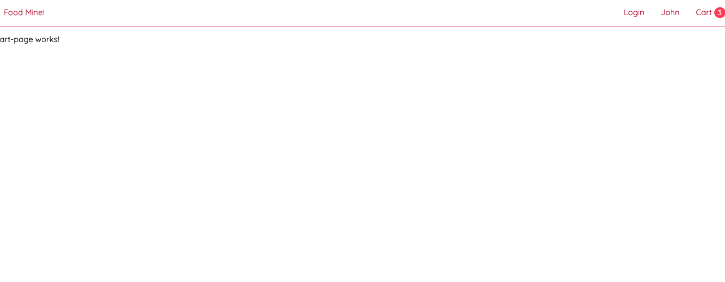

8. Cart Page

1. ﻿﻿﻿Create CartItem Model
2. ﻿﻿﻿Create Cart Model
3. ﻿﻿﻿Generate Cart service
4. ﻿﻿﻿Add to Cart Button in Food Page
5. ﻿﻿﻿Generate Cart page component
6. ﻿﻿﻿Add Route
7. ﻿﻿﻿Add ts I
8. ﻿﻿﻿Add html

﻿﻿﻿Add css

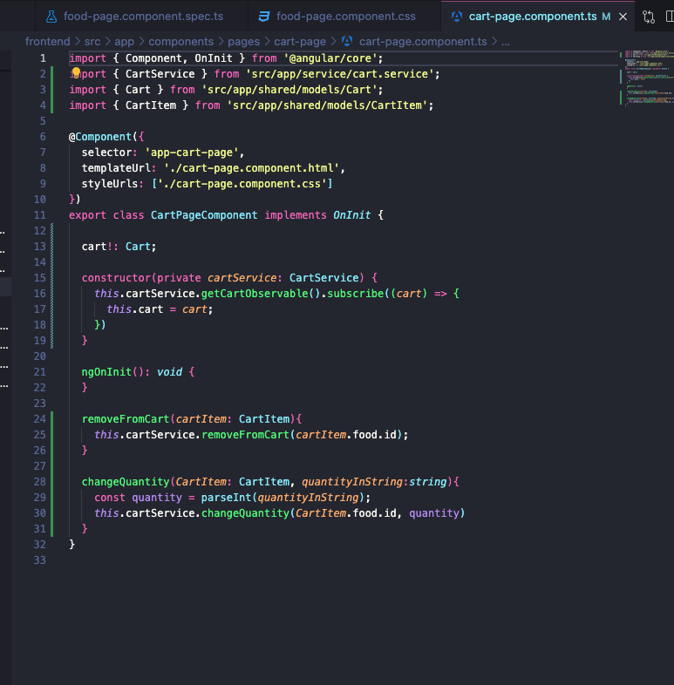

*ng g c components/partials/title*

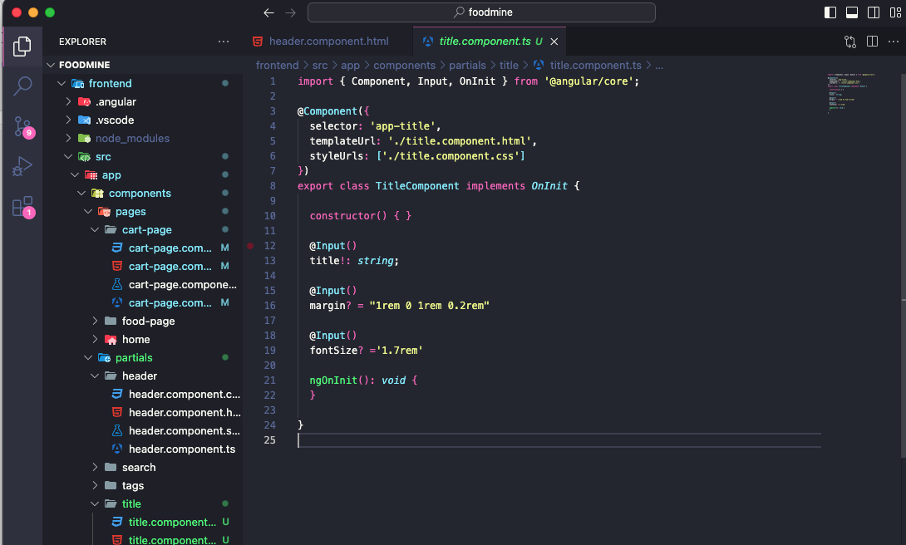

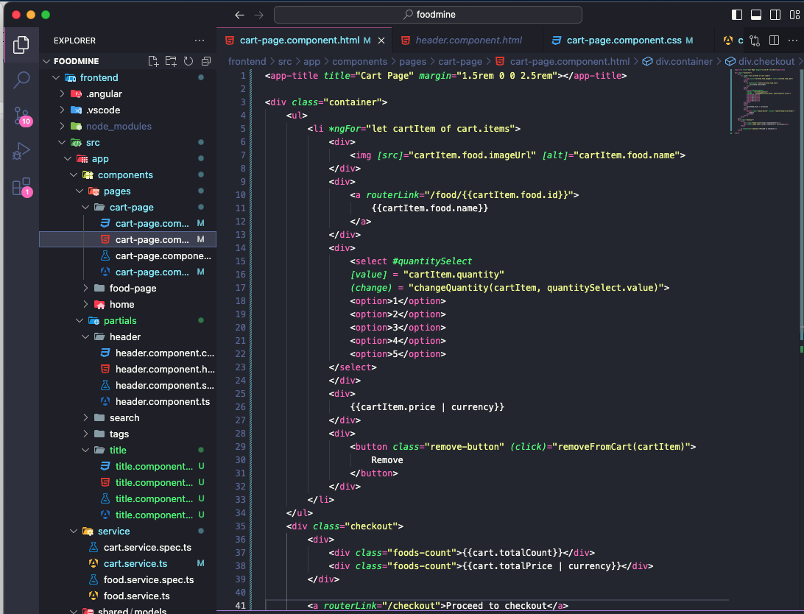

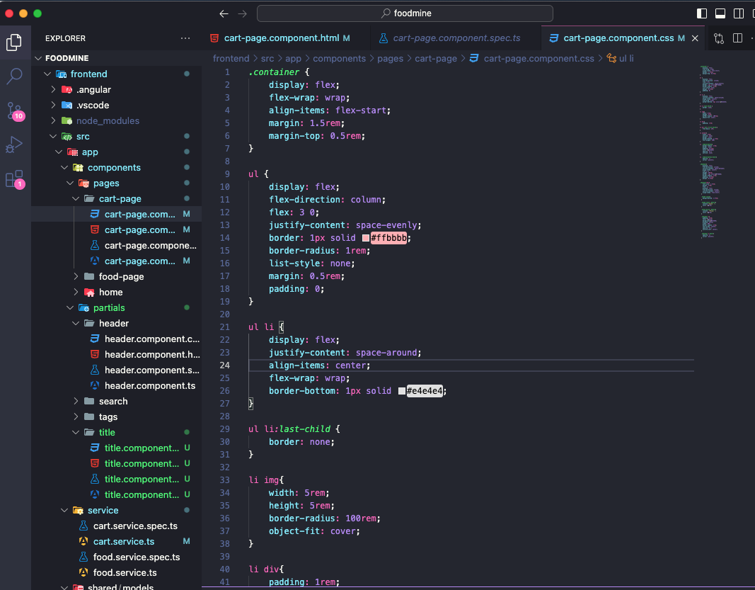

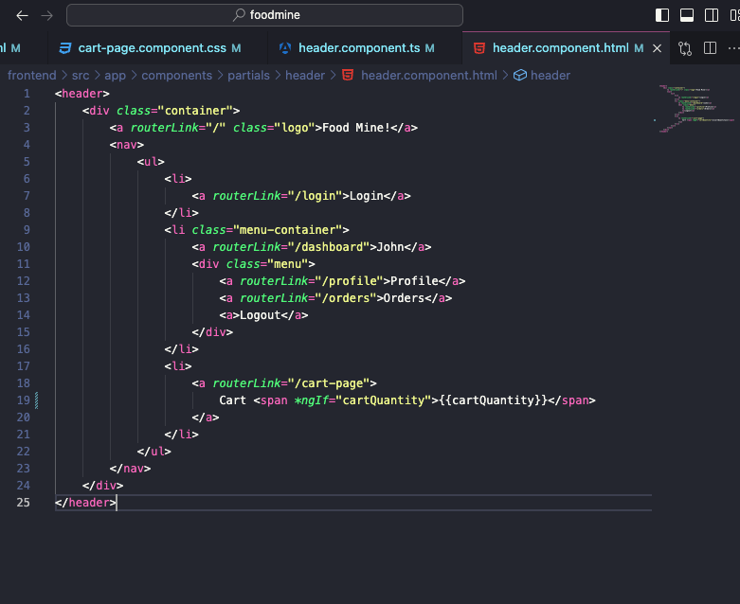

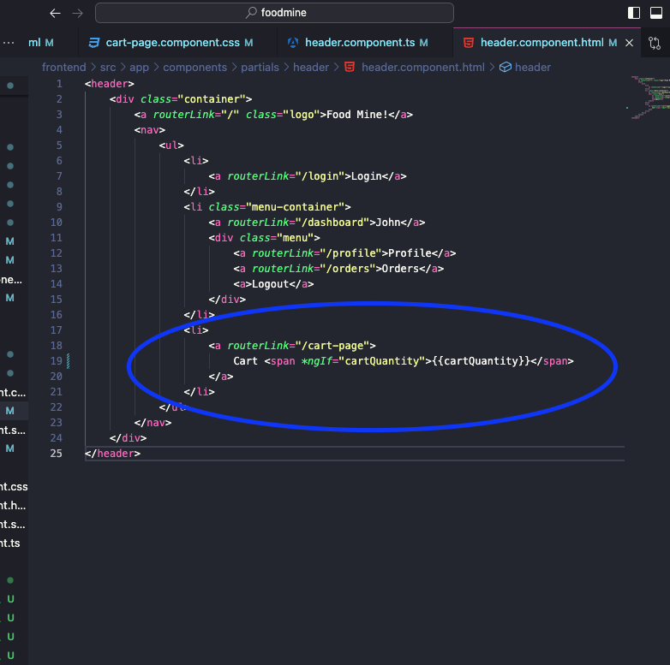

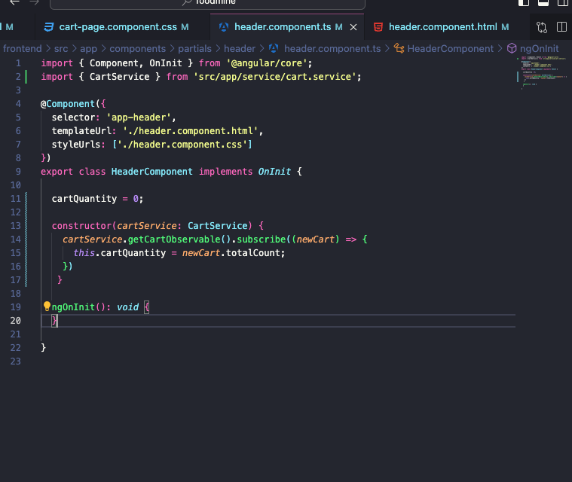

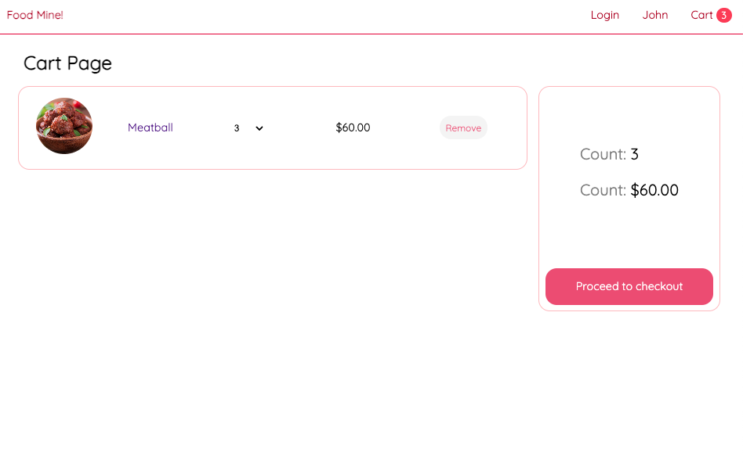

Not found

10. Not Found!

1. Generate Component

1. ﻿﻿﻿Add ts
2. ﻿﻿﻿Add html
3. ﻿﻿﻿Add css

2. Add To Pages

1. ﻿﻿﻿Home Page
2. ﻿﻿﻿Food Page

﻿﻿﻿Cart Page

1

Ng g c components/partials/not-found

2

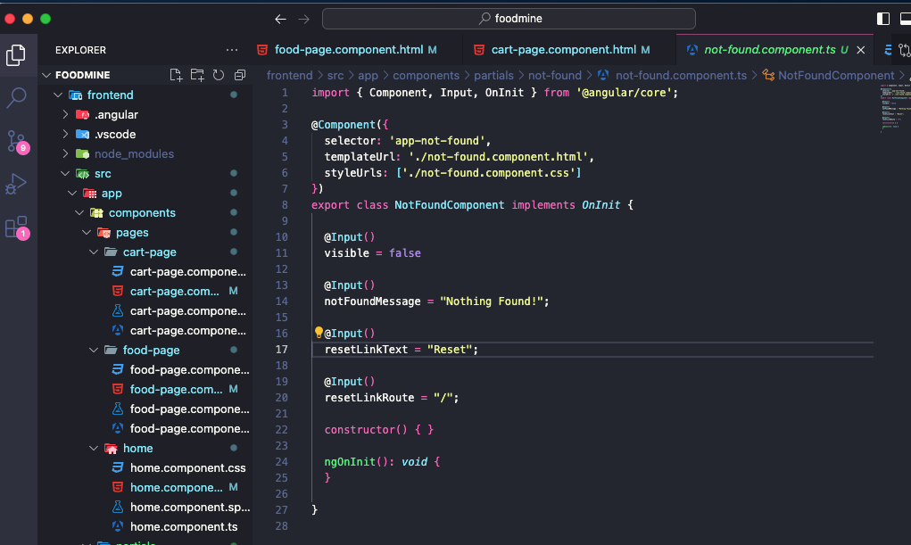

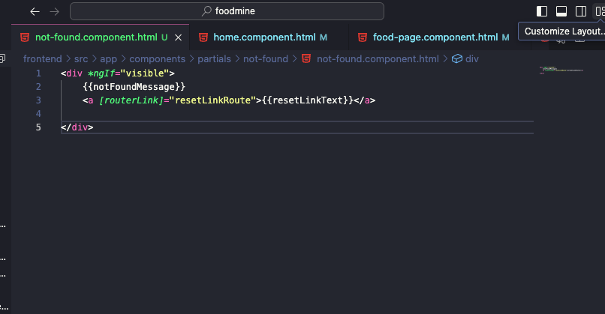

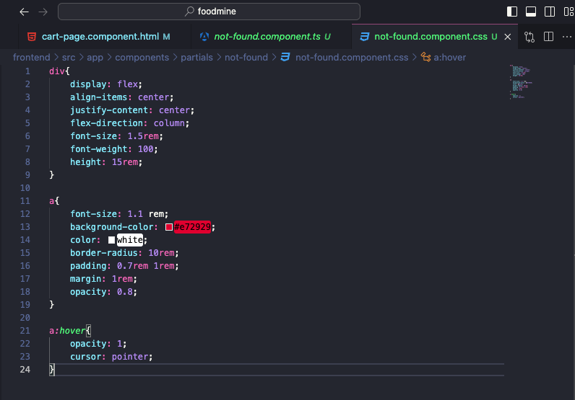

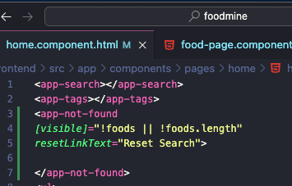

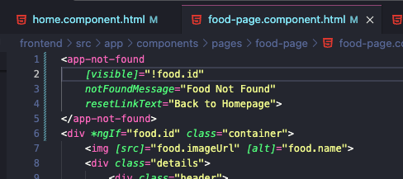

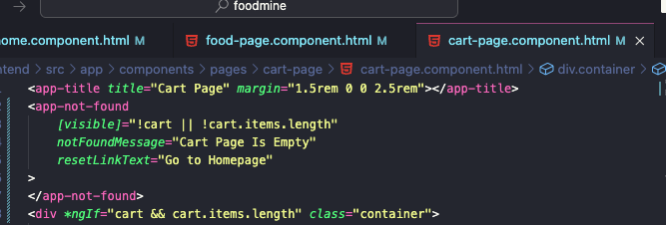

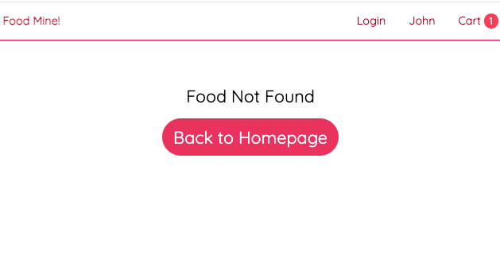

Connect To Backend

1. ﻿﻿﻿Create backend folder
2. ﻿﻿﻿npm init
3. ﻿﻿﻿npm install typescript
4. ﻿﻿﻿Create tsconfig json
5. ﻿﻿﻿Create • gitignore
6. ﻿﻿﻿Copy data.ts to backend/src
7. ﻿﻿﻿npm install express cors
8. ﻿﻿﻿Create server.ts
9. ﻿﻿﻿install @types
10. ﻿﻿﻿Add Apis
11. ﻿﻿﻿npm install nodemon ts-node --save-dev
12. ﻿﻿﻿﻿Add urs.ts to frontend

esta

1. ﻿﻿﻿﻿Add HttpClient module

﻿﻿﻿﻿Update food

*Npm init -y*

pasta backend

*npm install typescript*

Criar arquivo tsconfig.json e colar

{

"compilerOptions": {

"module": "CommonJS",

"moduleResolution": "node",

"strict": true,

"outDir": "./built",

"experimentalDecorators": true,

"emitDecoratorMetadata": true,

"esModuleInterop": true

},

"include": ["src/**/*"],

}

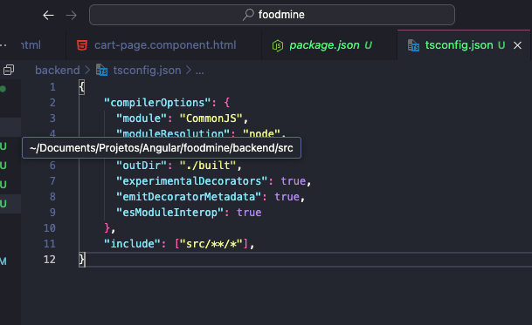

Criar arquivo .gitignore

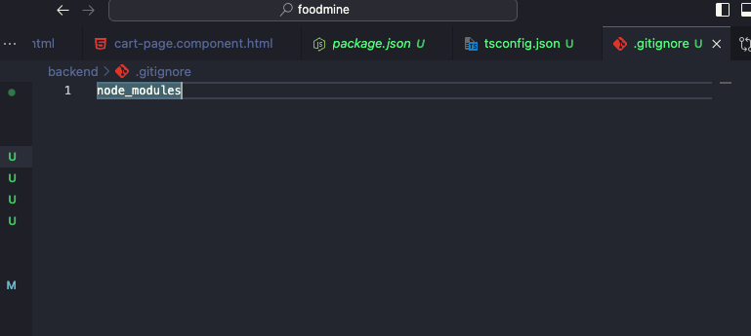

Copiando data.ts para pasta src dentro de backend

*Npm install express*

*sudo npm install @types/express*

*Npm install cors*

*sudo npm install @types/cors*

Criara arquivo server.ts

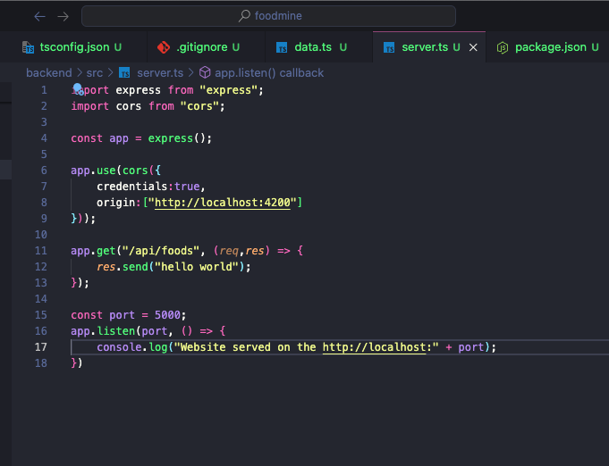

*sudo npm install ts-node --save-dev //converter para javascript*

*sudo npm install nodemon – save-dev*

Adding start

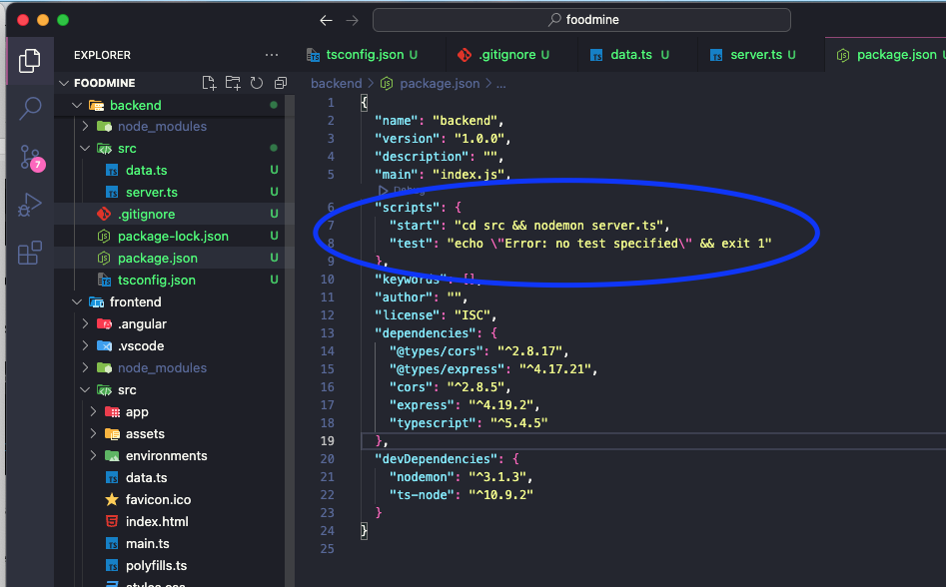

*Npm start*

*Instal json formater extension*

Implementar todos os metodos em food.service.ts no backend side

